**DMC**

**DATE: 17 December 2018**

**TIME: 13:00 – 16:45**

**ATTENDEES** Tom Gibbs, Elliot Chester, Henry Crofts

***COMMON ROOM***

**Sprint Aims:**

* **Review playtest feedback from weekend since last group jam**
* **Discuss how to and implement solutions to any issues identified**
* **Confirm group build is up-to-date and ensure exported to devices for client presentation**
* **Prepare materials for Wednesday’s client presentation**
* **Create recording of application demonstration**
* **All group members must complete project post-mortems by sprint end**

**Meeting Minutes:**

All team in attendance. Studio-jam started.

Team began by discussing playtest outcomes.

Some of the team members reported that they failed to get target number of playtesters the group had hoped for (10 testers).

Henry advised this was due to last-minute cancelled family plans so he lacked access to number of testers required.

Team agree that from the feedback given only the highlighted negative issues require attention, and that all other application attributes (whether mentioned positively, or not acknowledged) meet the clients requirements and so will not be developed further.

Team used whiteboard to draw out all issues which require attention.

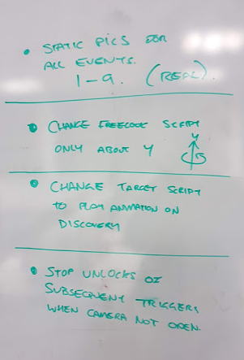

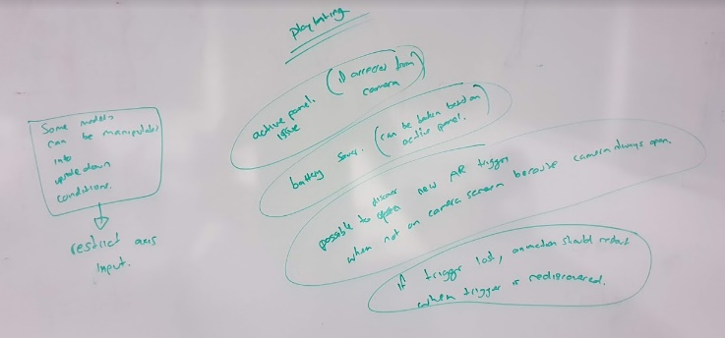

* Some models can be manipulated into inverted positions
* Subsequent events can be unlocked even when users are not on the camera screen
* Battery saver can be interfered with
* Issue with the currently selected panel
* If trigger is lost during poster detection, animation continues from point when it was lost

Team began working through rectifying these issues, delegating work based on who had produced the original functionality, while also ensuring that each member had a fair amount of work to complete.

Team soon realized that more time than had been reserved within sprint 10/12/18 would be required to complete the changes. Tom closed the sprint beginning 10/12/18 and started new sprint 17/12/18 which also allocates more time to rectifying issues identified in playtesting.

Once complete, the team tested the application to confirm that these behaviors are no longer repeatable.

Team confirm updates successful.

Team moved onto preparing the materials needed for the final DMC module client presentation.

Team are confident in the strength of previous presentations given and will maintain the established format.

Team printed off reference material to aide in client understanding during presentation.

* As usual reference materials contain flowchart of screen transitions and screen screenshots.
* Team made sure to prepare comparison screenshots of old and new elements that have been amended as per the client’s feedback, for easier assessment by the client.
* Old and new poster designs were printed, with A4 and A3 variants as promised to the client.

As usual team will provide a disclaimer regarding the visual sprites and models, confirming to the client that most are placeholder and the final versions are awaited from external contributors.

Team will then begin presentation as normal:

* Tom will introduce application to client, describing the AR functionality of the app, and how a user would interact with AR trigger material using the device camera.
* Henry and Tom will take turns introducing each AR event (2-9), while Elliot demonstrates the application on his laptop (using the laptop’s touch screen and camera).
* Henry and Tom will continue taking turns, talking through the navigation of the app, where information will be presented and the action of the mascot.

Team spent the remainder of the jam rehearsing the presentation.

Before leaving team discussed plans to arrive in Diss ahead of the scheduled presenting start.

Team lost a portion of pre-presentation meeting time in Diss at the last client presentation when there were traffic accidents both leaving Ipswich and entering Diss.

To avoid a repeat of this, Tom and Elliot will meet at the Atrium at 11:30 and drive to Diss.

All team will aim to meet at usual car park in Diss for 12:30, leaving 90minutes of additional preparation time to ensure that the presentation materials can be revised.

Next meeting arranged for Wednesday 19 December @ 11:30.

**Tasks for the current week:**

**(except postmortem) ALL TASK TO BE COMPLETED AS PART OF MONDAY JAM**

**ALL TEAM MEMBERS (9h):**

* **Resolve issues made apparent during team jam and playtesting sessions (1h 30m)**

As part of jam 17.12.18: From feedback gathered during the weekend, since the last team meeting, team must discuss any issues highlighted, how team can update project to rectify issues, then implement solutions.

* **Internally playtest the application to ensure issues rectified (30m)**

As part of jam 17.12.18: Once further issues have been corrected, team must internally playtest the application – attempting to recreate playtest issues – to confirm that all issues have been rectified.

* **Attend Group meeting to prepare and rehearse for module's final client presentation (4h 30m)**

Prepare presentation, physical materials required and rehearse delivery of presentation ahead of client meeting.

* Speaking topics and roles to be assigned
* Example posters for application demonstration to be printed
* elements of development plan to be extracted and printed
* demonstration of application to be prepared and rehearsed
* presentation of application to be rehearsed
* recorded demonstration of the application to be recorded
* **Final presentation to client (1h 30m)**

Travel to client's premises to deliver final presentation of fully functional app (application not inclusive of final models or audio).

* **Complete module postmortem (1h)**

To be completed independently. Each member must complete a postmortem as provided by Rob Kurta. Submit this to group repository.

Must be uploaded to the group within [root folder -> Postmortems]

**Detailed task breakdown, task descriptions and time estimates added to JIRA sprint.**